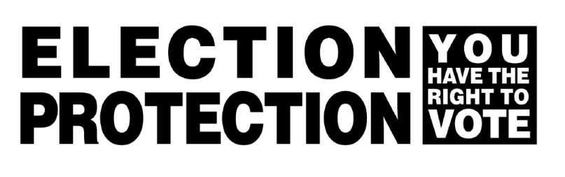  1-866-OUR-VOTE  (1-866-687-8683)  YOU HAVE THE RIGHT:  To vote if you registered by October 17, 2018.  To vote on a provisional ballot if your name is not on the list and believe you are registered at the polling place.  To vote if you cannot read or write English.  To bring a friend into the voting booth to help you vote.  To an accessible polling place if you have a disability.  To vote if you have gone to prison as long as you have registered since release (you can be on parole or probation and still vote).  To receive up to two new ballots if you make a mistake.  To bring materials into the voting booth for yourself.  To vote as long as you are in line by 8 p.m.  CALL 1-866-OUR-VOTE for information or to report problems |  | 1-866-OUR-VOTE  (1-866-687-8683)  YOU HAVE THE RIGHT:  To vote if you registered by October 17, 2018.  To vote on a provisional ballot if your name is not on the list and believe you are registered at the polling place.  To vote if you cannot read or write English.  To bring a friend into the voting booth to help you vote.  To an accessible polling place if you have a disability.  To vote if you have gone to prison as long as you have registered since release (you can be on parole or probation and still vote).  To receive up to two new ballots if you make a mistake.  To bring materials into the voting booth for yourself.  To vote as long as you are in line by 8 p.m.  CALL 1-866-OUR-VOTE for information or to report problems
1-866-OUR-VOTE  (1-866-687-8683)  YOU HAVE THE RIGHT:  To vote if you registered by October 17, 2018.  To vote on a provisional ballot if your name is not on the list and believe you are registered at the polling place.  To vote if you cannot read or write English.  To bring a friend into the voting booth to help you vote.  To an accessible polling place if you have a disability.  To vote if you have gone to prison as long as you have registered since release (you can be on parole or probation and still vote).  To receive up to two new ballots if you make a mistake.  To bring materials into the voting booth for yourself.  To vote as long as you are in line by 8 p.m.  CALL 1-866-OUR-VOTE for information or to report problems |  | 1-866-OUR-VOTE  (1-866-687-8683)  YOU HAVE THE RIGHT:  To vote if you registered by October 17, 2018.  To vote on a provisional ballot if your name is not on the list and believe you are registered at the polling place.  To vote if you cannot read or write English.  To bring a friend into the voting booth to help you vote.  To an accessible polling place if you have a disability.  To vote if you have gone to prison as long as you have registered since release (you can be on parole or probation and still vote).  To receive up to two new ballots if you make a mistake.  To bring materials into the voting booth for yourself.  To vote as long as you are in line by 8 p.m.  CALL 1-866-OUR-VOTE for information or to report problems

